Lab 09.01 Databases

Using databases

### Overview

I am assuming that you have done the database module last term, so this lab is just a refresher for you.

### Before the lab

Install a mysql database on your machine, if you do not already have one.

##### Windows

I recommend installing WAMP, go to

<http://www.wampserver.com/en/download-wampserver-64bits/>

You may need to install the Microsoft C++ dll to get it to work, link is on the download page. Make sure that you get the same version (32bit or 64 bit) as your wampserver.

##### mac/linux

Download MySQL from mysql.com

<https://dev.mysql.com/downloads/installer/>

you may want the MySQLworkbench as well to make connections and run the sql.

NOTE: I am assuming that you have already done this in the database module so have not gone into it in great detail

## Mysql

1. Create a table in mysql called *student* that has three columns (id, firstname, age), id will be auto_increment
   1. Open a mysql console
   2. When you login to mysql you are not in any particular database to see the databases use the command

show databases;

* 1. To create a database

create database *datarep;*

* 1. To use a database

use datarep

* 1. Create the table in the database with the command

create table *student* (

id int NOT NULL auto_increment,

firstname varchar(100),

age int(3),

PRIMARY KEY(id)

);

insert data

insert into *student* (firstname, age) values (’joe’,56);

view data

select * from student;

Updata data

update student set firstname=’mary’ where id = 1;

Delete

Delete from student where id = 1;

Make sure you do not forget the semi colon (;) if you are stuck in the middle of a command use ctrl-c

1. Make a table called book that has 4 columns (id, title, author, price) and insert some data into it.
2. Look at the tables in phpmyadmin.

## View data –

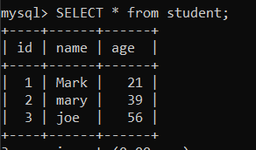

Update data –

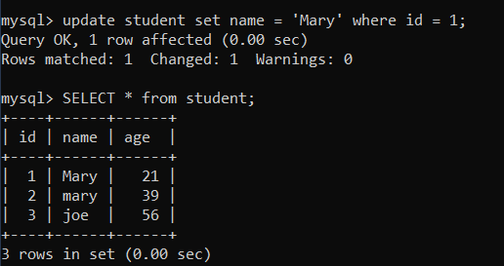

Delete data –

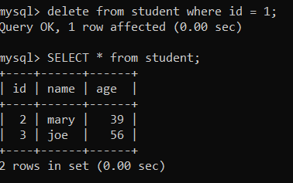

Create book table –

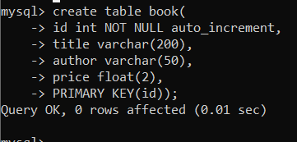

Php view –

